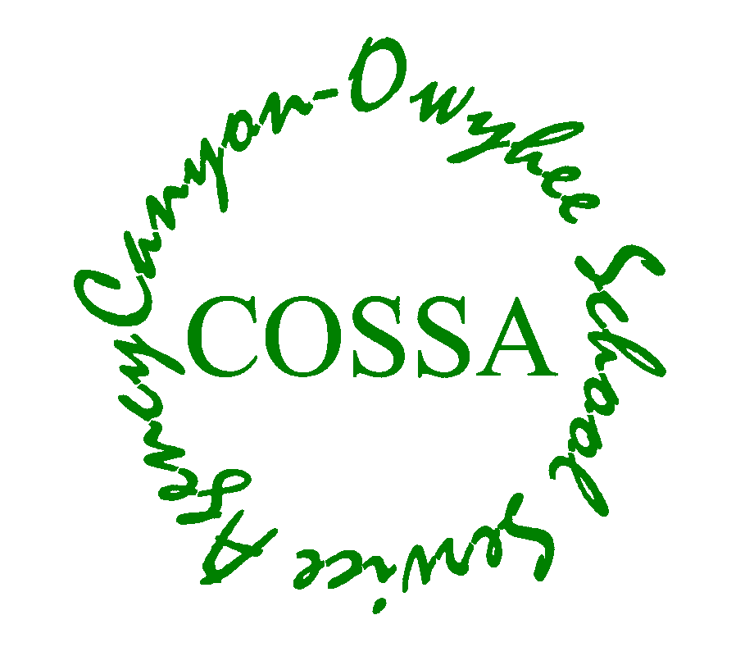
CANYON-OWYHEE SCHOOL SERVICE AGENCY
109 Penny Lane
Wilder, ID 83676
Phone (208) 482-6074
Fax (208) 482-7904

COSSA
Instructional
Procedures Manual
Effective August 19, 2019

Canyon-Owyhee School Service Agency (COSSA) is a public school cooperative serving the special education, Career-technical, and alternative education needs of students from Homedale, Marsing, Notus, Parma, and Wilder School Districts.
Table of Contents

Table of Contents 2

Manual Purpose and CRTEC’s Guiding Educational Principles 3

Master Course Schedule 4

Standards and Curriculum Alignment 5

Student Performance Standards 7

Student Data Analysis 8

Proper Placement - STAR Renaissance Testing 9

Advisory 10

Early Warning System (EWS), Response to Intervention (RtI), Remediation 11

Specific Teaching Aids

Writing Standard 14

Formative Assessment Plan 16

Purpose of the Instructional Procedures Manual

The CRTEC Instructional Procedures Manual has one overriding purpose: standardization of common educational forms and processes so all CRTEC teachers are not wasting time developing the forms and processes already agreed upon by the staff. The manual is not meant to reduce academic freedom, rather to free teachers from having to develop their own forms and processes.

CRTEC’s Guiding Educational Principles

1. Student learning and student safety is the focus of every CRTEC staff member.

2. Staff are aware and alert to adverse childhood experiences our students face, and remain trauma-sensitive in every student interaction.

3. Proper placement helps ensure student success. Students will be placed into grade-level classes based on their ability to succeed in that class, as determined by placement testing and record review. Testing and record review occur PRIOR to enrollment in class. Placement is based on performance on an exam, whether a standardized test or a specific placement test. COSSA Academy currently uses the Renaissance STAR test to determine grade-level equivalency. No student is placed into a class until the placement process is complete.

4. Escalating “help” is in place for students through the multi-tiered system of academic support (MTSS). Intervention and remediation efforts are part of the MTSS.

5. Teachers participate in a collaborative meeting once per week to talk about student performance and ways to ensure student academic success. Intervention and remediation efforts for struggling students are the main topics during this meeting.

6. Competency-based placement means students will be able to “challenge” face to face classes by taking the End of Course (EOC) exam. If they score 80% or higher, they will not have to take that class and will receive credit for that class.

7. Disciplinary actions take into account restorative justice principals and trauma-sensitive best practices.

Master Course Schedule

Every effort will be made to create a four-year master course schedule and then to adhere to that schedule of courses. This will ensure that teachers have adequate time to plan for courses that are coming up in their schedule.

In creating a master course schedule, some courses stand-alone, and some must occur sequentially. Examples:

Must have “A” before “B” “B” not dependent on “A”

Math English 9
Science English 10
History English 11
English 12

Standards and Curriculum Alignment

Standards Alignment Vision:

1. COSSA will adopt standards-based grading and reporting.

2. All course-related documents will be aligned to the Idaho Core Standards:

- Curriculum, scope & sequence, syllabi
- Assessments
- Instruction
- RtI/Remediation
- Report Cards/Reports to Parents

Specifically:

1. All basic documents contains standards. Basic documents include: Idaho Core Standards, Idaho Science Standards, CTE Competencies (SkillStack), etc.

2. From the basic documents we create COSSA Standards, which funnel down (reduce) the total number of standards to a manageable level for alternative/CTE students.

3. COSSA Standards become curriculum (“a student will be able to …”), which becomes syllabi and scope & sequence, which become lesson plans, which leads to assessments. Unless you follow the “backwards by design” method, which jumps to assessments and works backward through lessons to scope & sequence to curriculum.

3. Report cards/discussions with parents.

First – begin by referencing standards in all progress discussion
Goal – basing progress on standards (standards-based report cards)

Curriculum Alignment:

1. Curriculum alignment between similar courses taught by different teachers occurs during standards alignment. Divide and conquer, and then share with each other.

2. Alignment includes creating a common EOQ.

3. Alignment will occur for all “core classes”, as defined below:

Core Classes: Junior High and High School specific classes required for graduation. These will include:

Junior High:
- JH English
- JH Math
- JH Social Studies
- JH Science

High School:

English Department
- 9th grade English
- 10th grade English
- 11th grade English
- 12th grade English
- Speech

Math Department
- Algebra 1
- Geometry

Social Studies
- U.S. History
- Government
- Economics

Health

Sciences
- Earth Science
- Biology

Student Performance Standards

1. Acceptable Levels of Student Performance for “Growth”:

a. Growth: measured by the difference in the score on pre- and post-tests in a quarter-long course.

b. Growth Measure: the change in the percentage of correctly answered questions or performed skills, expressed in “percentage gain”.

For example: A student scores 20% on the pre-test and 40% on the post-test. The “change” is 20%.

c. Acceptable growth: 30%.

2. Acceptable Level of Student Performance for “Proficiency” at a standard:

a. Proficiency: measured as the percentage of the assessments and/or questions related to a specific (individual) standard that must be correct for a student to be considered proficient at that standard.

b. Acceptable Proficiency: 60%.

For example: Standard E9.2.3 has 5 related questions on the EOQ. A student correctly answers 3 of the 5. 3/5 = 60%. Therefore, the student has “passed” (is proficient at) Standard E9.2.3.

3. Acceptable Level of Student Performance for “Proficiency” at an EOQ:

a. Proficiency: measured as the percentage of the standards that we consider “essential” (all “COSSA Standards” for this course) at which a student must be proficient, for a student to be considered eligible to move to the next level of this subject.

b. Acceptable Proficiency: 70%.

For example: The Biology “A” course has 20 essential standards, and each standard has 5 questions on the EOQ. A student achieves “proficient” [answering correctly a minimum of 3 out of 5 questions per standard] on 15 of the 20 essential standards. 15/20 = 75%. Therefore, the student’s performance allows him/her to advance to the Biology “B” course.

Student Data Analysis

1. There are three levels of continuous improvement team (CIT) planning:

Level I - COSSA-Wide CIT
Level II – CRTEC, specifically CTE, CIT
Level III – COSSA Academy CIT

Student data is analyzed in the CRTEC and COSSA Academy CIT. COSSA Academy CIT:

a. Membership: all Academy teachers, data team, Admin.

b. Data to review: Student performance and growth (pre- & post-, EOQs, measures in the strategic plan).

c. Planning: Efforts to improve student performance and growth.

2. Teachers are evaluated on both student growth and performance, so the CIT can help identify areas of improvement for teachers.

3. COSSA Academy CIT Plan is to measure at the following frequency:

a. Strategic Plan items – annually

b. EOQ – quarterly

c. Pre- and post-tests – quarterly

*** Note: Insert the actual due dates established by the CIT in the spring of 2019

Proper Placement – STAR Renaissance Testing

STAR Testing

COSSA Academy uses the Renaissance STAR math and reading tests to determine grade-level-equivalence for all students who enter COSSA Academy. Testing occurs for all students three times per year – beginning of year, end of first semester, and end of second semester. Students new to COSSA Academy are tested shortly after admission. Some students who are very low in grade-level-equivalence may be tested more often to assess the effectiveness of intervention strategies.

STAR Incentives

Students will be positively incentivized to perform to their best on the STAR tests.

1. Incentivize student effort on STAR test.
2. Incentivize grade level equivalence OR scaled score positive movement.
3. Students assume ownership of their score.
4. Administration consistently schedules test, frequently.

Advisory Periods

COSSA Academy has one advisory period in each school day:

10 minutes at the beginning of the day.

The primary purpose of the morning advisory period is to allow Advisors to quickly check-in with students on their physical and mental health. This “early warning” of a student having a difficult day may allow counselors or others in the school to lower the student’s anxiety or other issue that will prevent that student from learning.

In addition, short lessons on various topics such as anti-bullying, or topical discussions on current events or holiday themes, may be undertaken.

Vision:

1. Relationship building. Get to the point where the Advisor understands not just what is happening, but why. Advisor is an advocate for the student. Example:

Monday teachers’ meeting: focus on academics and behavior,
but student’s advisor gives input/insight

2. Soft skills: work ethic, attitude, communication skills, problem solving – a lot like the “Success Class”. “Sharpen the saw” on skills developed in the Success Class.

3. Grade checks, wellness check-in, STAR grade equivalency discussion.

4. Goal setting: define goals, understand goals, set goals:
- Academic
- Personal/behavior

5. Students stay with same advisor long-term to develop relationship

6. New students are placed into Advisory with a teacher with whom they have at least one class.

RtI Referral Form

Date: __________________________________________

Student Name: ______________________________________________
GLE Reading: ___________ GLE Math: _____________
[Below 4th grade = remediation plan versus regular classes]

Meeting between Principal, Counselor, Parents, Student

Remediation Courses Assigned: _____________________________
_____________________________
_____________________________

Advisor: ___________________
[What is going on behind the scenes?] __________________________________
___________________________________________________________________

Early Warning System:

Attendance _______________________
Behavior _______________________
Grades:
Assignments ____________________________
Formative ____________________________
Quizzes ____________________________
Tests ____________________________

Remediation:
Academic Success ___________________________
Academic Probation ___________________________
In-class Diversity:
Different Assessment _______________________
One-on-one _______________________
Preferential Seating _______________________
Questions Read _______________________
Testing for Special Needs ____________________________
Full Academic Probation ____________________________

Counseling:

Substance _____________________________
Anger _____________________________
Mental Health ________________________
Pregnancy/Parenting ___________________
SWDH ______________________________

COSSA Academy Multi– Tiered Systems of Support
Academic
Systems (RTI)
Attendance
Supports
Behavioral
Systems (MBI)
Non-Academic
Counseling
Full Academic Probation
Special Education Referral
Remedial Instruction
Behavioral Intervention Plan (BIP)
Schedule Change
Special Education Referral

Orientation
Teaching/Modeling Universals
Current Discipline Process
“Act of Kindness”
Teaching of Behavior Expectations
* Handbook Quiz
* Active Supervision
* Handbook Signature
After School Program
* Anger Management
* WISE Guys
Parent Meeting
Behavior Contract
Truancy Petition
S.R.O. Home Visit
Attendance Contract
Student/Parent/School Meeting
Attendance Letter Home

Student Handbook Signature
Attendance Warning Letters Mailed Home
Automated System Calls Home @0900
STAR Testing
Awards Ceremony
Student Handbook Signing
Orientation
Partial Academic Probation
Parent Meeting
Academic Success
Anger Management
Substance Abuse
Mental Health
Access to Clothing

Deseret Industries Grant
Weekend Food Baskets
Pregnancy/Parenting
SWDH Medical Care
Tier 2—Targeted Group Interventions
Tier 3—Intensive, Individual Interventions
Academic Systems (RTI)
Attendance
Supports
Behavioral
Systems (MBI)
Non-academic
Counseling
Date:__________________________________________
Concern: __________________________________________________________________________________________________________________________
What We Know: _______________________________________________________________________________________________________________________
______________________________________________________________________________________________________________________________________
STUDENT:

COSSA Writing Standard

Standard English
- No text talk.
  - I don’t like what you are doing
  - I dnt like what ur doin
  - Appropriate voice/tone
- Avoid jargon
Punctuation
- End of sentences
  - period . question mark ? exclamation point !
- Proper comma use
  - Complex sentence, compound sentence, list, dialogue
Paragraphs
- Indent
- 4 or more sentences
- 1 idea per
Complete Sentences
Capital letter to begin
Subject and predicate (main clause = complete thought)
Correct punctuation to end

Verb = expresses action, condition, or state of being
Predicate = what the subject is, does, or has

-- - -- - -- - -- - -- - -- - -- - -- - -- - -- - -- - -- - -- - -- - -- - -- - -- - -- - -- - -- - -- - -- - -- -
Simple:
The dogs eat Cheerios.

My mom and dad hugged the baby.
The boy ran and swept the floor.
Bluebirds and owls really love to hunt and nest differently.

Complex Sentence:
While I walked to the store, I tripped over the sidewalk.

When brightly lit the lamp sheds a warm glow.

Compound Sentence:
He lost the green glove, but someone found it yesterday.

I learned that yellow cats love to scratch yarn and play with bells.

The office and computer labs were filled with the scent of the flowers in bloom and dust in the air.

Compound-Complex Sentence:
As I wrote the letter, the ink fell on the paper, and the stain covered the words.
As I wrote the letter, the ink fell on the paper and covered the words.

Complete Sentence +FANBOYS Complete Sentence
Subject blah blah predicate blah, FANBOYS subject blah predicate blah.

For / And / Nor / But / Or / Yet / So

Commas in lists:
Joey wants me to buy eggs, milk, and juice at the grocery store.
The dog ran, jumped, and landed in the swimming pool

Formative Assessment

CRTEC uses "exit tickets" as the CRTEC standard formative assessment. This includes CTE as well as COSSA Academy courses.

1. Definition of formative assessment:

Methods that teachers use to conduct in-process evaluations of student comprehension, learning needs, and academic progress during a lesson, unit, or course.

2. "Purpose" of formative assessments:

Formative assessments help teachers identify concepts that students are struggling to understand, skills they are having difficulty acquiring, or learning standards they have not yet achieved, so that adjustments can be made to lessons, instructional techniques, and academic support.

3. Definition of exit tickets:

Brief assignments, short quizzes, or simple tasks, that quickly collect student responses to a teacher's questions at the end of a lesson or class period.

4. "Purpose" of exit tickets:

Based on what the exit ticket responses indicate, the teacher can modify the next lesson to address concepts that students have failed to comprehend or skills they have not yet mastered.

5. Applicability:

"Exit tickets" can be used in almost every class or program taught within COSSA Academy and the Career & Technical School. Exit tickets will not look the same for every area, but the need to establish whether or not you need to re-teach a subject is universal. Exit tickets need not be used every day. They may more properly be used at the end of a unit. Again - how their use looks depends on your class, the structure of your learning environment, etc.

