COSSA DIESEL TECHNOLOGY DEPARTMENT
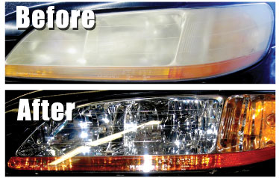

ANNUAL FALL COMMUNITY SERVICE DAY NOVEMBER 14TH 2019 FROM 3:00-7:00
COSSA DIESEL STUDENTS WILL BE RESTORING HEADLIGHTS THIS IS NORMALY A $60.00 DOLLAR VALUE WE ARE JUST ASKING FOR DONATIONS.
THIS MONEY GOSE DIRECTLY INTO THE STUDENTS DIESEL ACCOUNT TO AID THEM IN TRAVELING COST AND DUES FOR SKILLS USA.

